Course _______Specialist_____ Year ___12_____

Student name: ________________ Teacher name: ________________

Task type: Response

Time allowed for this task: ____40_______ mins

Number of questions: _____7______

Materials required: Calculator with CAS capability (to be provided by the student)

Standard items: Pens (blue/black preferred), pencils (including coloured), sharpener, correction fluid/tape, eraser, ruler, highlighters

Special items: Drawing instruments, templates, notes on one unfolded sheet of
A4 paper, and up to three calculators approved for use in the WACE examinations

Marks available: ___38___ marks

Task weighting: _10___%

Formula sheet provided: Yes

Note: All part questions worth more than 2 marks require working to obtain full marks.

Q1 (2, 2 & 3 = 7 marks) (3.1.1 to 3.1.3)
If & determine the following.

Solution
Specific behaviours
shows conjugate of z
obtains result

Solution
Specific behaviours
uses conjugate
obtains simplified result

Solution
Specific behaviours
expresses one fraction with real denominator showing use of conjugates
expresses both fractions with real denominators showing use of conjugates
simplified result
(answer only one mark)

Q2 (3 marks) (3.1.2)
Determine all possible pairs of real numbers such that
Solution

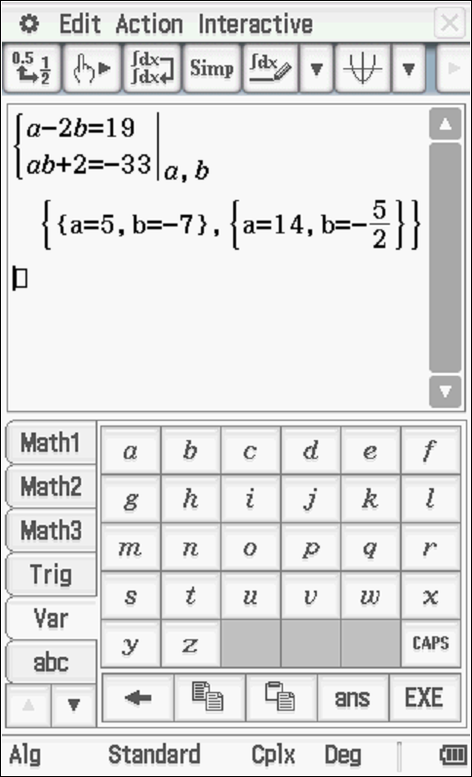

Specific behaviours
obtains one equation for a & b
states two simultaneous equations and solves for at least one pair
states two pairs of values
Q3 (2 & 3 = 5 marks) (3.1.13- 3.1.15)
Consider the function .
- Determine the remainder of when divided by .
- Solution
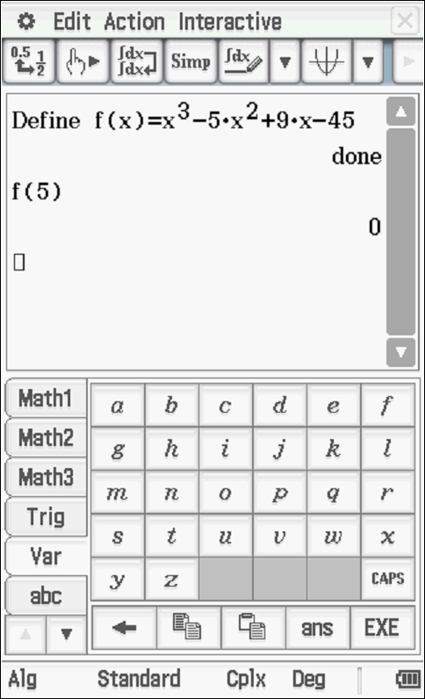

Specific behaviours
subs x=5
states zero remainder

- Show that is a factor of and hence determine all linear factors.

Solution
Specific behaviours
subs x=3i and shows the result of each term with the sum being zero
uses conjugate root stating two complex linear factors
states all 3 linear factors

Q4 (3 marks) (3.1.9)
Determine the complex number in the form with & .

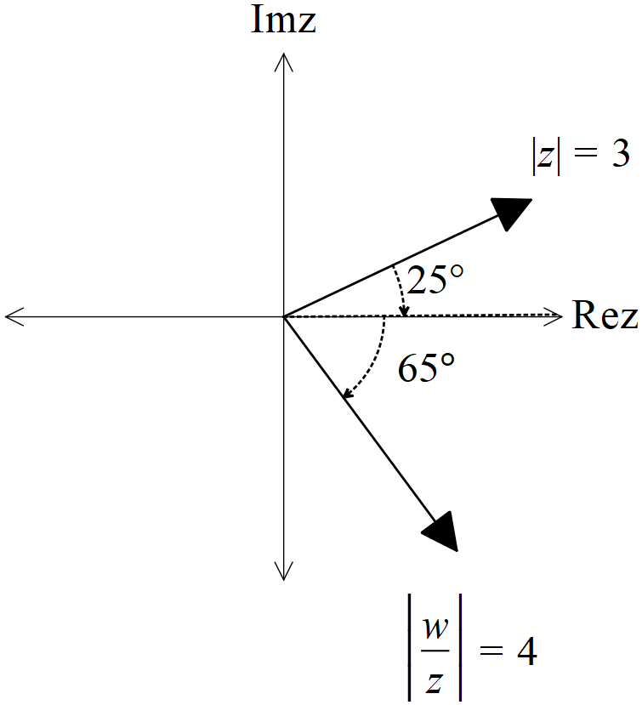

Solution
Specific behaviours
determines argument with working
states modulus
states in polar form with principal argument

Q5 (2, 2, 3 & 3 = 10 marks) (3.1.10)
Consider the following set of complex numbers such that .
Determine the following.
- Minimum value of .(exact)
Solution
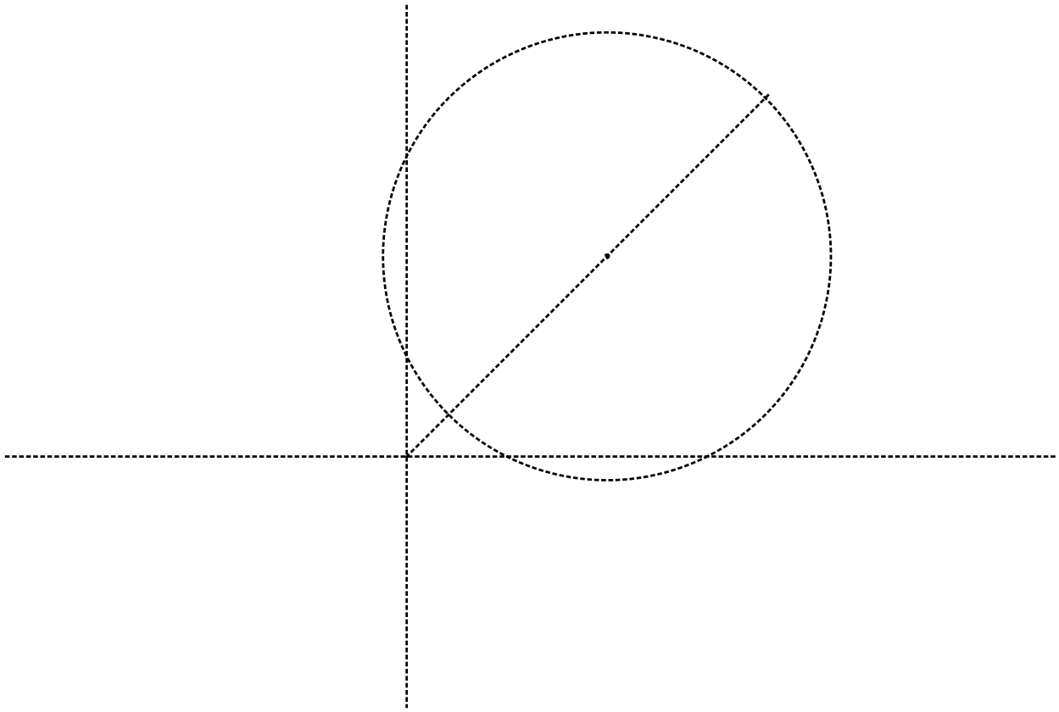
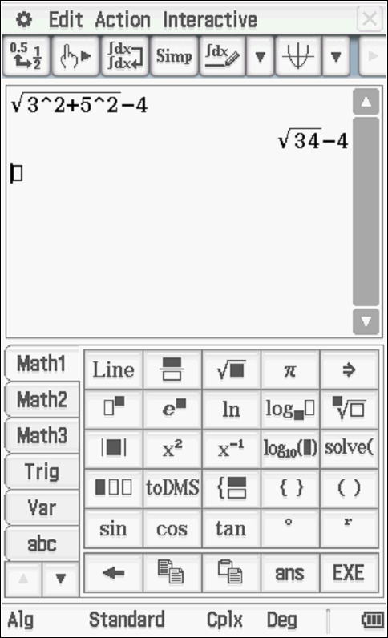

Specific behaviours
uses modulus of centre
states exact value

- Maximum value of .
Solution
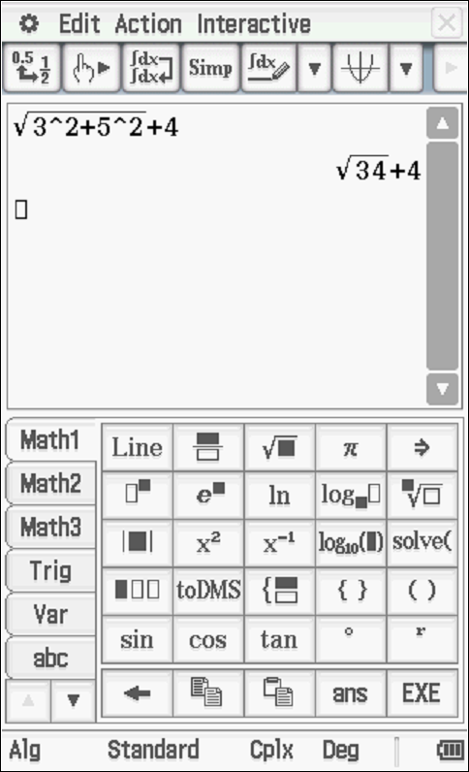

Specific behaviours
uses modulus of centre and ignores conjugate
states exact value

- Maximum value of Arg in radians to two decimal places.

Solution
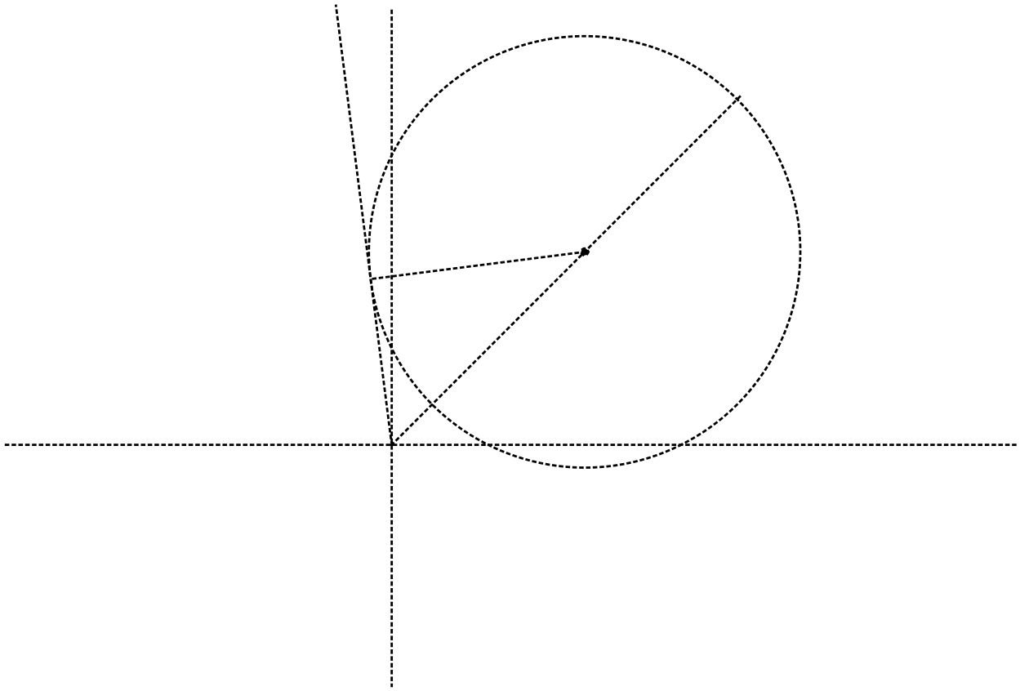

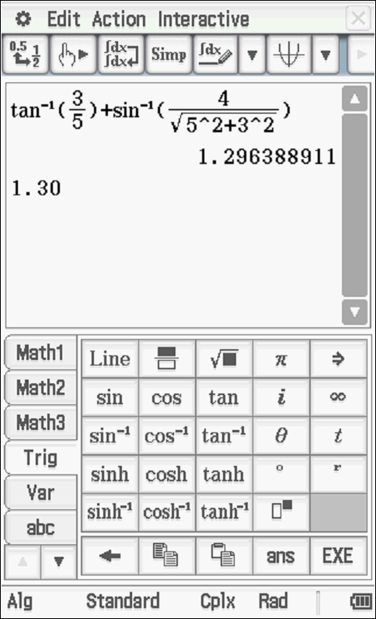
Specific behaviours
uses tangent line and finds argument of centre
uses inverse sine to find added argument to tangent
states argument rounded to 2 dp radians

- Maximum value of (exact)

Solution
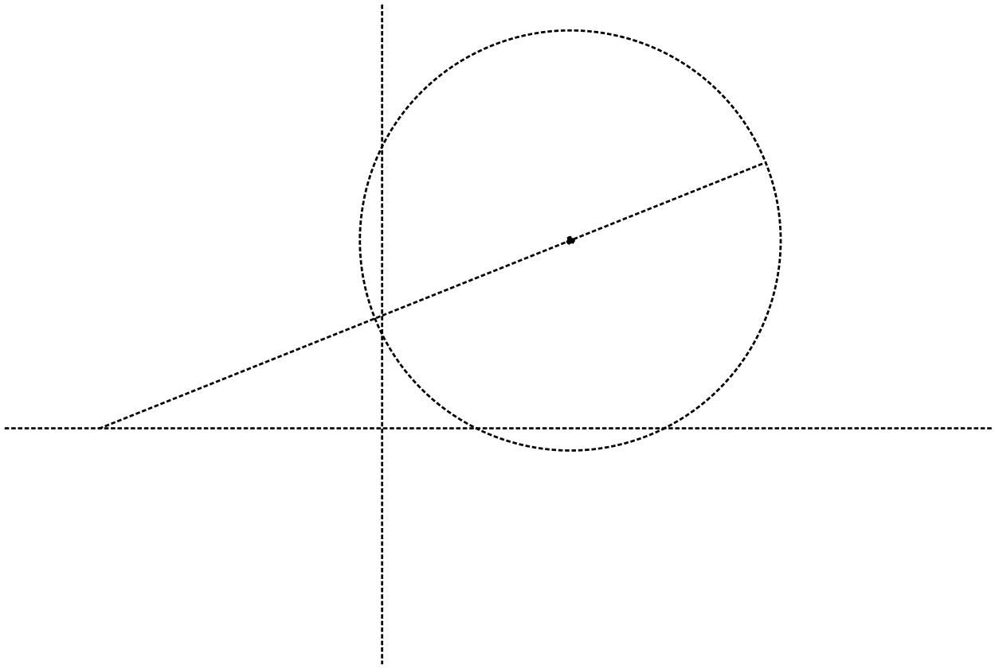
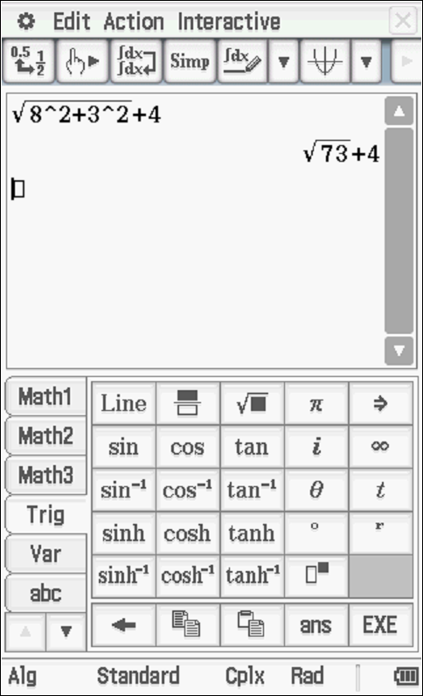

Specific behaviours
use distance from -3 on real axis
determine distance to centre from -3
adds radius to give maximum distance

Q6 (3 & 3 = 6 marks) (3.1.6)
Let be complex numbers such that
- Determine the exact value of Arg() in principal form (i.e )

Solution
Specific behaviours
multiplies Arg(p) by 5
determines argument of q
determines final principal argument of s

- Determine the exact value of

Solution
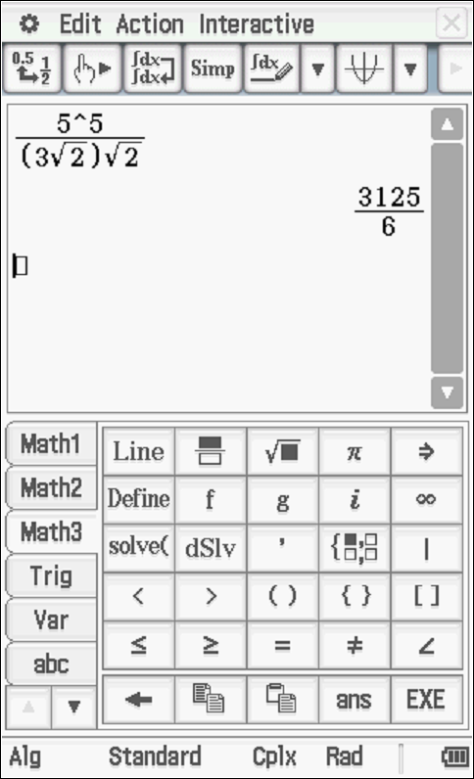

Specific behaviours
raises mod of p to power of 5
determines mod of both terms in denominator
determines exact result

Q7 (4 marks) (3.1.10)

Sketch the locus of complex numbers that satisfy both of the following
AND in the Argand diagram below.

Solution
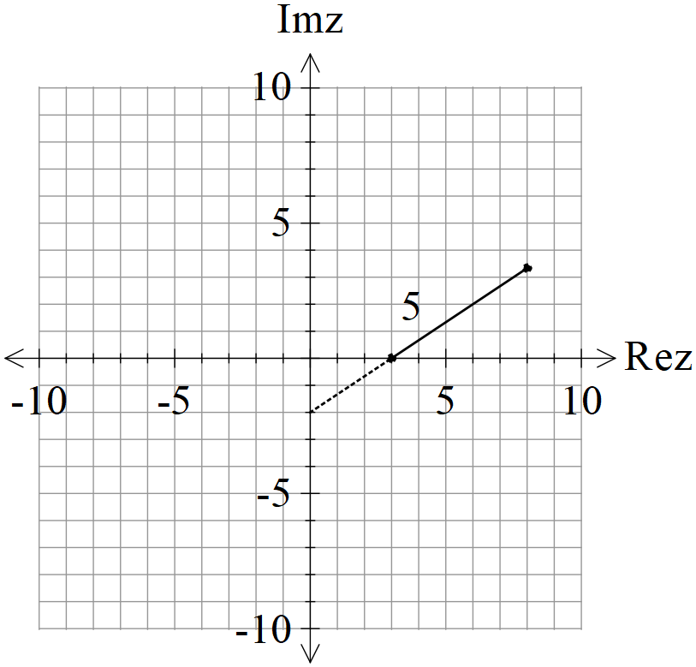

Specific behaviours
uses line that when extended passes through -2 on imaginary axis (dotted)
has line passing through 3 on real axis
only allows part of line above real axis
shows that line only has a length of 5 units

